METHOD STATEMENT: Tissue Puffs
Tissue puffs should not be used to pack small objects already packed in tissue in the event they are mistaken for packaging alone and are disposed of in error. Therefore, when unpacking check tissue puffs and nests thoroughly before disposal.

Trays with Tissue Puffs
Suitable for: Small to medium sizes objects with stable robust surfaces not excessive in weight.

What you will need:
Nitrile gloves
Tray
Plastazote tray liner - 3mm

Method:
- Select a tray of suitable height dependent on the height of objects to pack.
- Place a plastazote tray liner in the base of the tray.
- Using acid-free tissue make a tissue puff or nest for each object. Depending on space availability in the tray and size and weight of the object use one or two sheets of tissue to make nests of varying densities.
- Wearing gloves move one object into the tray at a time placing on to a tissue nest.
When placing objects into trays try to:
- Position the objects in the tray on their most stable side.
- Try to position objects so accession numbers if present are visible therefore to avoid excess handling of the object in the future. All objects coming off display should have been given a Tyvek label with their accession number. Place, tie with cotton tape or pin this label next to the object.
- Position objects to distribute weight evenly across the tray.
- Position objects of similar material and substance together when possible (e.g. Do not place heavy items next to fragile delicate items).
- Do not overpack objects into trays. Ensure accessibility of objects when packed.

- Place tissue puffs around the object to provide support and prevent movement in the tray. Tissue puffs should be placed so that the flat, smooth side is facing the object. Ensure there is sufficient packing material underneath and around each object and adequate space between each object.
- Place any essential information about the tray contents on the outside of the tray (e.g. fragile objects, objects protrude above the edge of the tray, the weight of the tray is excessive, uneven weight distribution, hazardous objects contained, toxic substances present).

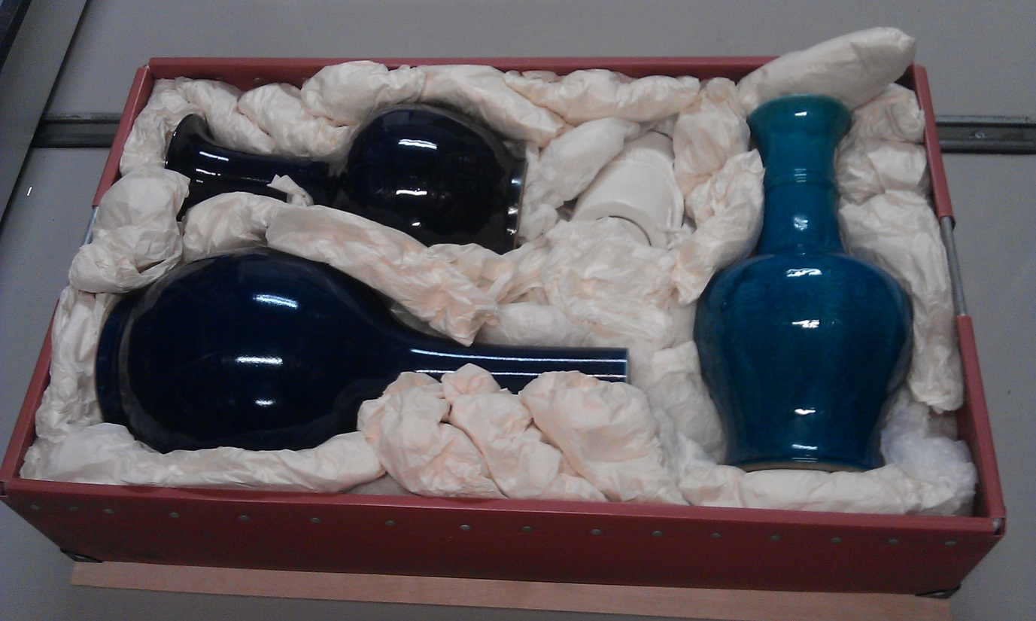
Image 1. Glazed ceramics packed in a red fibre tray cushioned with acid-free tissue puffs. Note the weight distribution and sufficient space between each item.

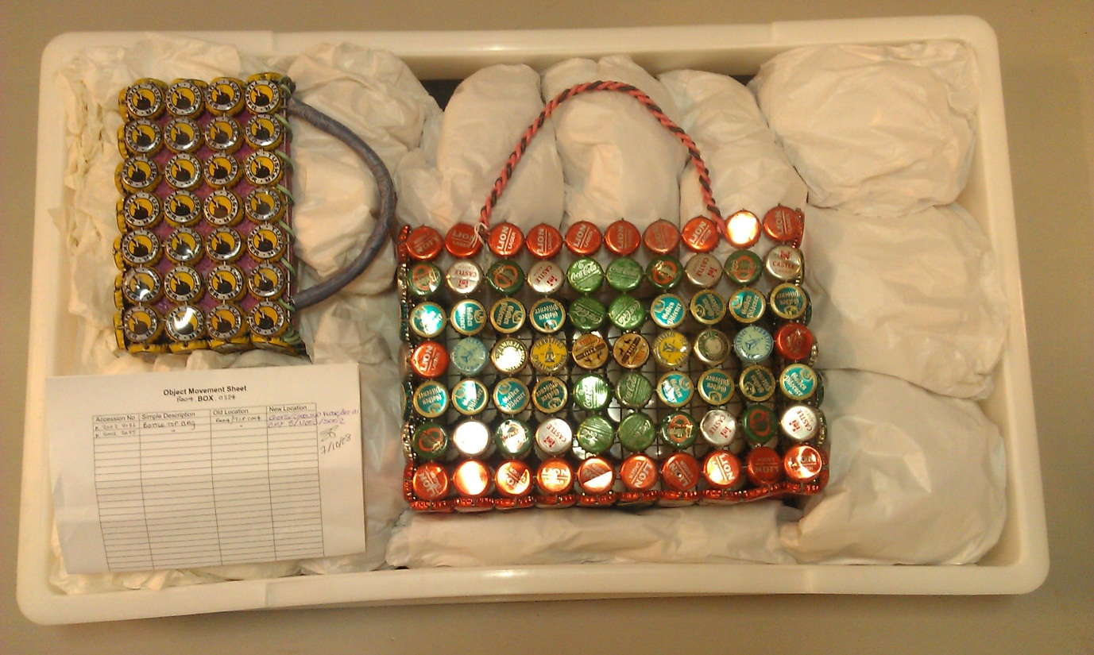
Image 2. Metal objects packed with large acid-free tissue puffs. Note the excess space filled in with tissue to provide overall support.

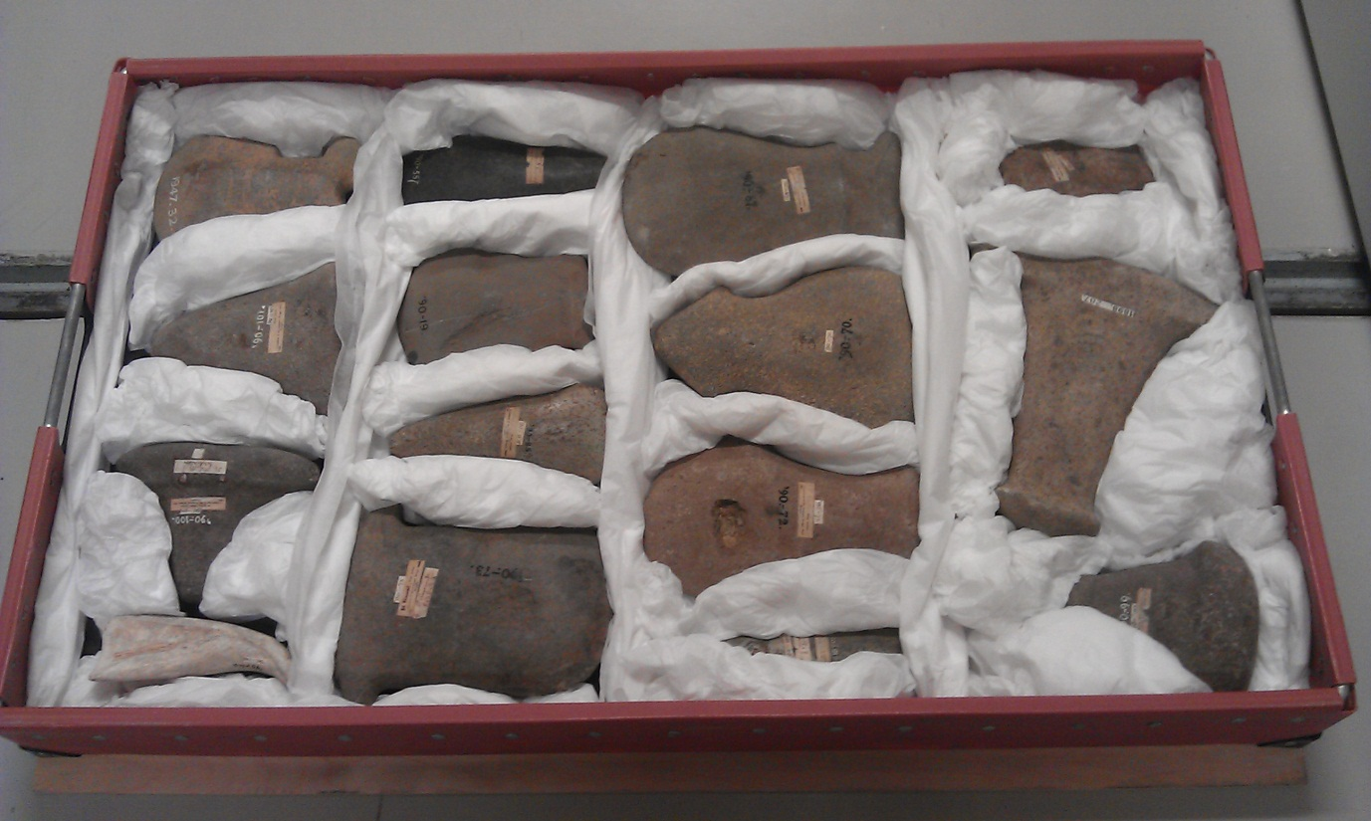
Image 3. Stone objects packed with acid-free tissue nests and sausages. Note the positioning of items in the tray with accession numbers visible and sufficient space and packaging between items to prevent contact.

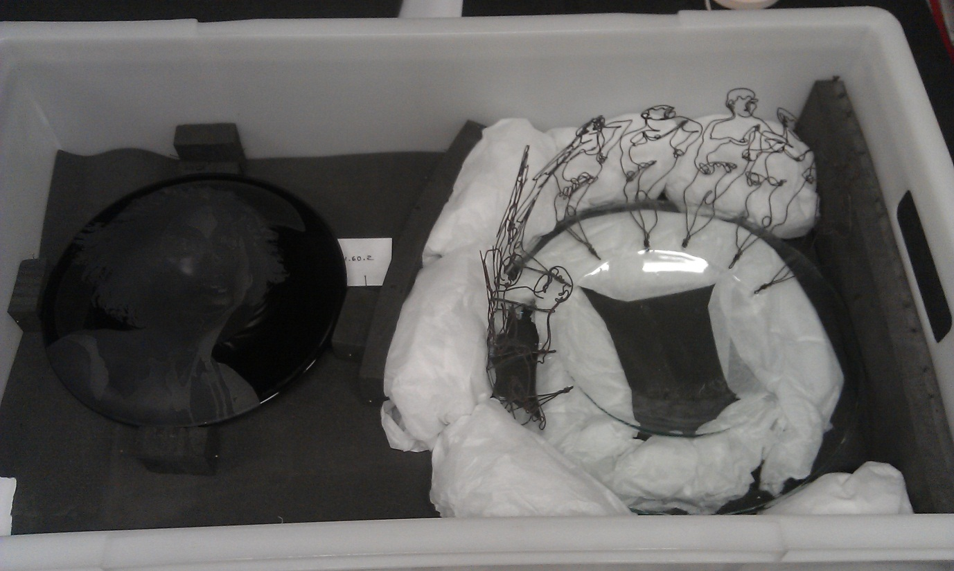
Image 4. Glass objects packed using a combination of both tissue puffs and plastazote. Blocks can hold tissue puffs in place against delicate surfaces.

Boxes with tissue puffs
Suitable for: Oversize objects with smooth robust surfaces.

What you will need:
Nitrile gloves
Acid-free card box / Polyethylene box.
Plastazote tray liners or thick sheets
Acid-Free tissue paper
Bubble wrap

Method:
- Place a plastazote tray liner in the base of the box. Bubble wrap can also be used but be sure to fold the bubble wrap inwards so the bubbles are facing away from the object. Place acid-free tissue over the bubble wrap.
- Wearing gloves move one object into the box at a time. Ensure weight of objects are dispersed evenly inside the box.
- Make tissue puffs of acid-free tissue and place around the base of the object. Make sure the smooth tissue surface is in contact with the object surface.
- Pad around the object to the top.
- Double up tissue sheets to make larger puffs to fill in the voids or use bubble wrapped in tissue for extra padding and support around large objects. (Roll the bubble wrap ensuring the bubbles are facing inward then cover entirely with tissue) Place around the object ensuring no bubble is in contact with the object surface.
- Pad out box to lid and place lid on.
- Place any essential information about the contents on the outside of the box (e.g. fragile objects, the weight if excessive, uneven weight distribution, hazardous objects contained, toxic substances present).
Packing Tip
Particularly fragile small objects can be packed into individual crystal boxes (Image 4). The object sits between 2 tissue puffs placed in each side of the container. Accession numbers can be written directly on to the box lid and boxes can then be pinned into bread trays.
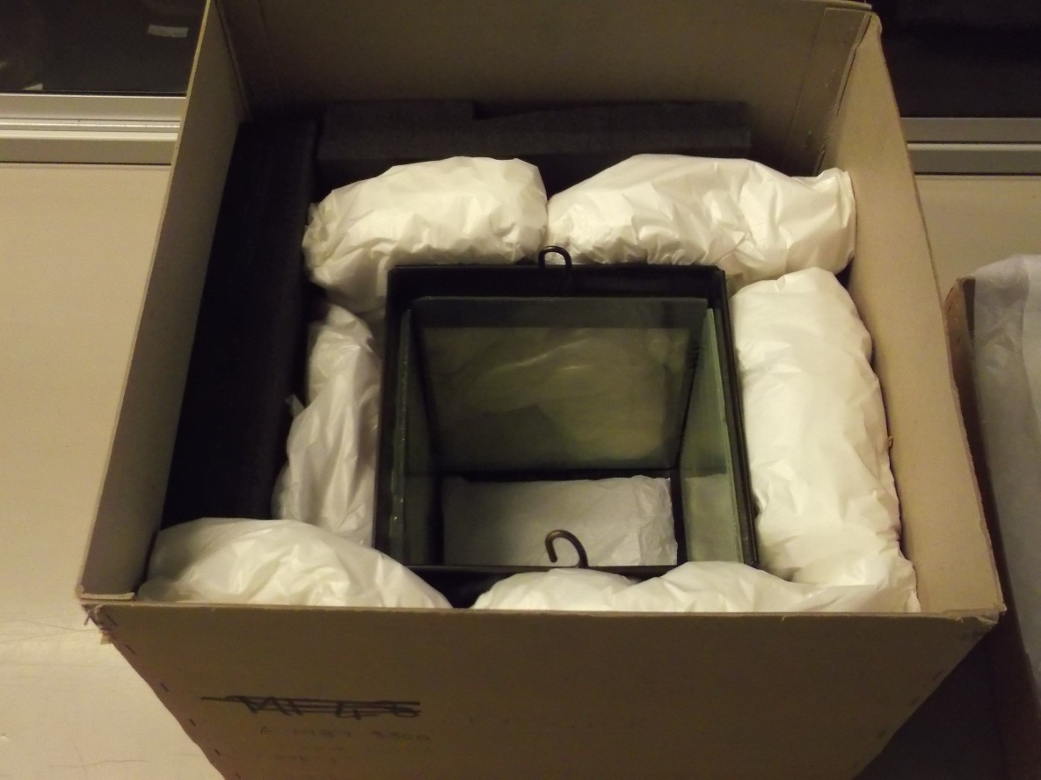
Image 1. Glass and metal oversize object embedded in an acid-free card box. Packed with thick plastazote lining and large acid-free tissue puffs for cushioning.

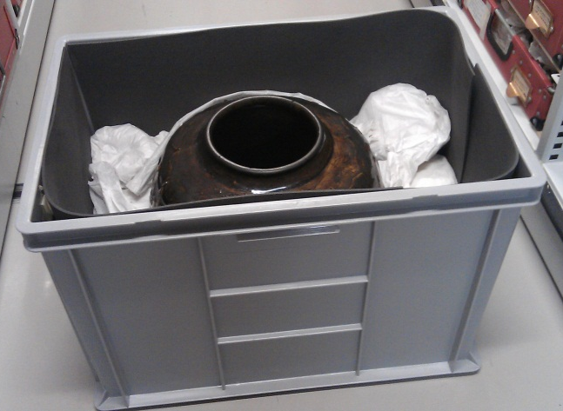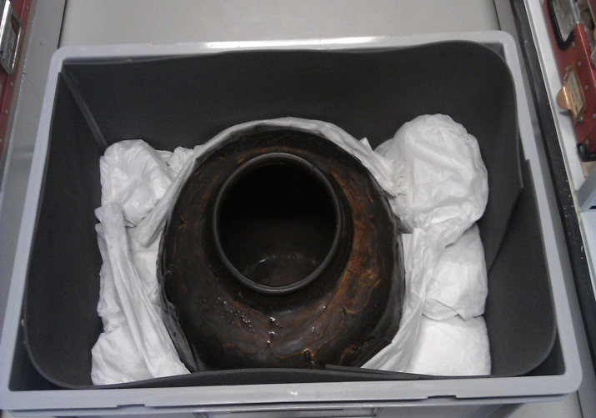
Image 2. Oversize glazed ceramic vase packed in a polyethylene box lined with plastazote. Buffered with bubble wrapped in acid-free tissue.
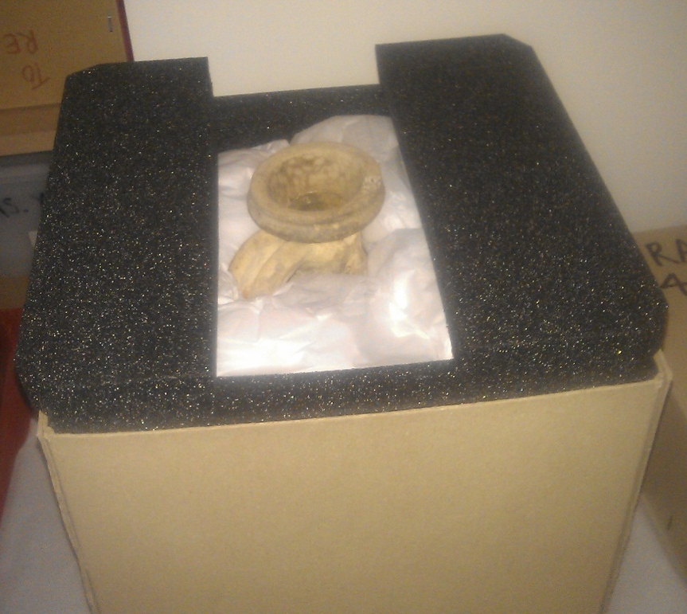
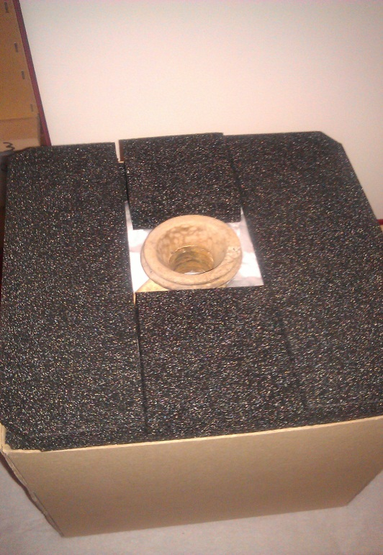
Image.3 Pottery jug cushioned with acid-free tissue puffs in an acid-free card box. Thick plastazote blocks can be used to line the box and build up the height to further protect the item.

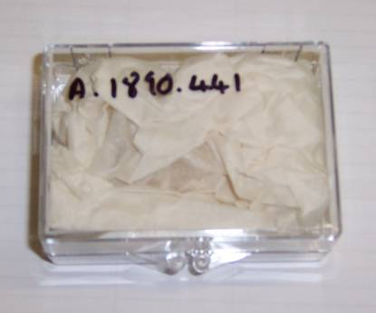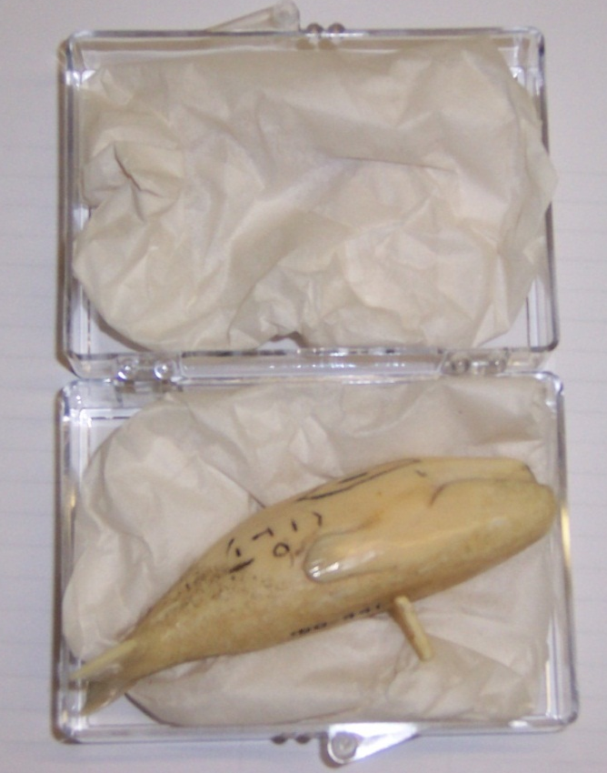
Image 4. Small ivory object packed into individual crystal box. Note smooth acid-free tissue surface facing towards object.

